DESIGN AND DEVELOPMENT OF
ELECTRIC BIKE

[Project Report]

ABSTRACT
The increasing demand for sustainable transportation, rising fuel costs and growing environmental concerns have accelerated the development of electric vehicles as an efficient alternative to conventional fuel-powered transportation. This project presents the design and development of an Electric Bike that provides an economical, environment friendly and energy-efficient solution for short and medium-distance travel purpose. The proposed system integrates a Brushless DC (BLDC) motor powered by a lithium-ion battery pack, offering high efficiency, low maintenance and reliable performance.
The electric bike is designed with a lightweight yet durable frame that accommodates the battery pack, motor, controller, and other essential electrical components while maintaining proper weight distribution and rider comfort. A high-performance BLDC motor is selected to deliver smooth acceleration and a maximum speed suitable for urban transportation. The lithium-ion battery provides sufficient energy storage to achieve an extended driving range on a single charge while reducing charging frequency and operating costs.
The vehicle incorporates an LCD display that provides real-time information, including speed, battery level, trip distance and other operational parameters, enabling the rider to monitor the system effectively. For enhanced safety, the bike is equipped with Brembo hydraulic disc brakes, providing reliable braking performance under various riding conditions. The suspension system consists of hydraulic telescopic front forks and adjustable rear shock absorbers, ensuring improved ride comfort, vehicle stability and effective vibration damping on uneven road surfaces.
The design process includes component selection, system modeling, mechanical layout, electrical integration and performance analysis to ensure efficient operation and structural reliability. The completed design demonstrates the practical application of electric vehicle technology by combining efficiency, safety, durability, and rider comfort within a compact two-wheeled platform. This project highlights the potential of electric bikes as a sustainable mode of transportation capable of reducing fuel consumption, lowering greenhouse gas emissions and minimizing maintenance costs while meeting the daily mobility requirements of modern society.

TABLE OF CONTENTS:
Sr No. | TOPICS | Page No.
1. | OBJECTIVES | 4
2. | PROBLEMS | 5-6
3. | PROPOSED SOLUTIONS | 7-10
4. | COMPONENTS AND MATERIALS USED WITH SPECIFICATIONS | 10-16
5. | DESIGN CALCULATIONS | 17-23
6. | FABRICATION PROCESS | 23
7. | ASSEMBLY PROCESS | 23
8. | WORKING PRINCIPLE | 24
9. | COST ESTIMATION | 24-25
10. | LIMITATIONS OF THE PROPOSED MODEL | 25-26
11. | CONCLUSION | 26
12. | CAD MODEL AND ASSEMBLY | 27-28
13. | REFERENCES | 29

- Objectives
- Design and develop an electric bike capable of safely carrying two adult riders with a strong and durable frame.
- Select a 2 kW BLDC motor and a 60 V lithium-ion battery to achieve a maximum speed of approximately 50 km/h with efficient power delivery.
- Integrate an efficient electrical drive system comprising the BLDC motor, motor controller, battery management system (BMS), and throttle for smooth and reliable operation.
- Equip the bike with a multifunction LCD display to provide real-time information such as speed, battery level, and trip distance.
- Enhance rider safety by incorporating Brembo hydraulic disc brakes and a hydraulic suspension system for superior braking performance and riding comfort.
- Evaluate the bike's performance in terms of speed, load-carrying capacity, battery range, structural stability, and overall efficiency to ensure compliance with the design objectives.

- PROBLEMS
The transportation sector is one of the largest contributors to fuel consumption and environmental pollution. Conventional fuel-powered motorcycles, although widely used, suffer from several drawbacks related to efficiency, operating cost, and environmental impact. Likewise, many existing electric bikes available in the market utilize low-cost components that compromise performance, reliability, and rider comfort. These limitations motivated the development of the proposed electric bike using an optimized combination of modern electrical and mechanical components.
Problems Associated with Fuel-Based Motorcycles
1. High Fuel Consumption
Conventional motorcycles rely on petrol or diesel, whose prices continue to increase over time. Daily commuting results in significant fuel expenses, making transportation costly for users.
2. Environmental Pollution
Internal combustion engines emit harmful gases such as carbon dioxide (CO₂), carbon monoxide (CO), nitrogen oxides (NOₓ), and unburned hydrocarbons, contributing to global warming and air pollution.
3. High Maintenance Requirements
Fuel-powered engines consist of numerous moving parts that require regular servicing, including engine oil replacement, spark plug maintenance, clutch adjustments, air filter cleaning, and exhaust system servicing.
4. Low Energy Efficiency
A large portion of the fuel's energy is lost as heat through the engine and exhaust system, resulting in comparatively lower overall efficiency than electric propulsion systems.
5. Noise and Vibration
Combustion engines generate considerable noise and vibration, reducing rider comfort and contributing to noise pollution in urban environments.
6. Dependence on Fossil Fuels
Fuel-powered motorcycles rely entirely on non-renewable fossil fuels, making them unsustainable as fuel resources continue to diminish.
Problems Found in Many Existing Electric Bikes
Although electric bikes eliminate many of the disadvantages of fuel-powered motorcycles, several commercially available low-cost electric bikes still exhibit notable limitations.
1. Use of Brushed DC Motors
Many entry-level electric bikes employ brushed DC motors due to their lower initial cost. However, these motors have brushes that wear over time, require frequent maintenance, generate heat, and operate with lower efficiency.
2. Lead-Acid Batteries
Some electric bikes continue to use lead-acid batteries because of their low purchase price. These batteries are heavy, have lower energy density, longer charging times, shorter service life, and provide limited travel range.
3. Basic Mechanical Braking Systems
Low-cost electric bikes often use mechanical drum or cable-operated disc brakes, which offer lower braking performance and require frequent adjustment compared to hydraulic braking systems.
4. Conventional Suspension Systems
Basic spring suspension provides limited vibration damping and reduced comfort, especially when traveling on uneven roads or carrying additional load.
5. Lack of Smart Monitoring
Many economical electric bikes lack digital displays, preventing riders from monitoring battery percentage, speed, trip distance, and system status accurately.
6. Reduced Performance
The combination of low-capacity batteries and lower-efficiency motors often results in reduced acceleration, lower maximum speed, and shorter travel distance per charge.

- PROPOSED SOLUTION
To overcome the limitations of conventional motorcycles and existing electric bikes, the proposed electric bike incorporates a carefully selected combination of electrical and mechanical components that improve efficiency, safety, reliability, and rider comfort.

1. BLDC Motor Instead of a Brushed DC Motor
A Brushless DC (BLDC) motor is selected as the propulsion system due to its superior performance and efficiency.

Brushed DC Motor | BLDC Motor (Selected)
Brushes wear out with time | Brushless construction eliminates wear
Requires regular maintenance | Virtually maintenance-free
Lower efficiency | Higher efficiency (typically 85–95%)
Generates more heat | Better thermal performance
Shorter lifespan | Longer operational life
Lower torque | Higher torque-to-weight ratio

Reason for Selection:
The BLDC motor offers higher efficiency, smoother operation, reduced maintenance, and longer service life, making it ideal for electric vehicles.

2. Lithium-Ion Battery Instead of Lead-Acid Battery
The proposed bike uses a Lithium-Ion battery pack rather than a lead-acid battery.

Lead-Acid Battery | Lithium-Ion Battery (Selected)
Heavy | Lightweight
Lower energy density | Higher energy density
Shorter lifespan | Longer cycle life
Slow charging | Faster charging
Higher maintenance | Maintenance-free
Lower travel range | Greater travel range

Reason for Selection:
Lithium-ion batteries significantly reduce vehicle weight while increasing range, charging efficiency, and overall battery life.

3. Hydraulic Brembo Disc Brakes Instead of Mechanical Brakes
For the braking system, Brembo hydraulic disc brakes are employed.

Mechanical Brakes | Brembo Hydraulic Disc Brakes (Selected)
Higher braking effort | Lower lever effort
Less precise braking | Excellent braking control
Requires cable adjustment | Self-adjusting hydraulic system
Reduced stopping performance | Superior stopping power
Reason for Selection:
Hydraulic disc brakes provide shorter stopping distances, improved safety, and consistent braking performance in both dry and wet conditions.

4. Hydraulic Suspension Instead of Conventional Spring Suspension
The proposed bike utilizes hydraulic telescopic front forks and adjustable rear hydraulic shock absorbers.

Conventional Suspension | Hydraulic Suspension (Selected)
Limited damping | Excellent vibration damping
Reduced comfort | Improved ride comfort
Less stability | Better handling and stability
Lower adaptability | Adjustable for varying road conditions

Reason for Selection:
Hydraulic suspension enhances rider comfort, minimizes vibration, and improves vehicle stability across different terrains.

5. LCD Display Instead of Analog Indicators
The bike is equipped with a modern LCD display.

Analog Meter | LCD Display (Selected)
Limited information | Multiple real-time parameters
Difficult to monitor battery | Accurate battery monitoring
No trip information | Trip and odometer functions
No fault indication | Diagnostic and warning indicators
Reason for Selection:
The LCD display provides comprehensive real-time information, enabling better rider awareness and efficient battery management.

- Materials and Components Used and Specifications
4.1. Frame and Chassis
Parameter | Specification
Material | Mild Steel (AISI 1018 / ASTM A36)
Manufacturing Process | MIG Welding
Shape | Rectangular & Circular Hollow Sections
Wall Thickness | 2.5–3 mm
Factor of Safety | ≥ 2
Reason for Selection:
- High structural strength
- Good weldability
- Economical
- Easily available
- Suitable for carrying two adults

4.2. Electric Motor
Parameter | Specification
Type | Brushless DC (BLDC) Hub Motor
Rated Power | 2000 W (2 kW)
Rated Voltage | 60 V
Peak Torque | 70–80 Nm
Rated Speed | 650–700 RPM
Maximum Vehicle Speed | ≈ 50 km/h
Cooling | Air Cooled
Efficiency | 88–92%
Reason for Selection:
- High efficiency
- Maintenance-free
- High starting torque
- Long service life

4.3. Battery Pack
Parameter | Specification
Type | Lithium-Ion
Voltage | 60 V
Capacity | 30 Ah
Energy | 1800 Wh (1.8 kWh)
Cell Type | 18650 or 21700 Lithium-Ion Cells
Battery Management System | Integrated BMS
Charging Time | 5–6 Hours
Estimated Range
Approximately 60–70 km per full charge

4.4. Motor Controller
Parameter | Specification
Type | BLDC Controller
Rated Voltage | 60 V
Current Rating | 40–45 A
Control Method | PWM
Protection | Over-current, Over-voltage, Under-voltage, Short Circuit

4.5. Battery Management System (BMS)
Parameter | Specification
Battery Compatibility | 60 V Lithium-Ion
Continuous Current | 45 A
Functions | Cell Balancing, Over-charge Protection, Over-discharge Protection, Short Circuit Protection

4.6. Throttle
Parameter | Specification
Type | Hall Effect Twist Throttle
Operating Voltage | 5 V
Output Signal | 1–4 V

4.7. Display
Parameter | Specification
Type | LCD Display
Display Functions | Speed, Battery Percentage, Odometer, Trip Meter, Voltage, Error Codes
Backlight | LED

4.8. Braking System
Parameter | Specification
Brand | Brembo
Type | Hydraulic Disc Brakes
Front Disc | 220 mm
Rear Disc | 220 mm
Brake Fluid | DOT 4

4.9. Front Suspension
Parameter | Specification
Type | Hydraulic Telescopic Fork
Travel | 120 mm
Material | High Strength Steel

4.10. Rear Suspension
Parameter | Specification
Type | Adjustable Hydraulic Mono Shock
Travel | 100 mm
Spring Type | Coil Spring

4.11. Wheels
Parameter | Specification
Material | Cast Aluminum Alloy
Diameter | 17 inches
Rim Type | Alloy

4.12. Tires
Parameter | Specification
Front Tire | 90/90–17
Rear Tire | 100/80–17
Type | Tubeless Radial

4.13. Handlebar
Parameter | Specification
Material | Aluminum Alloy
Width | 400 mm

4.14. Seat
Parameter | Specification
Type | Dual Rider Seat
Cushion Material | High Density PU Foam
Cover Material | Waterproof Leatherette

4.15. Lighting System
Parameter | Specification
Headlight | LED
Tail Light | LED
Turn Indicators | LED
Brake Light | LED

4.16. Charger
Parameter | Specification
Type | Smart Lithium-Ion Charger
Input | 220–240 VAC
Output | 67.2 V DC
Charging Current | 5 A

4.17. Wiring
Parameter | Specification
Material | Copper
Insulation | PVC
Wire Gauge | 10–18 AWG (depending on load)

4.18. Fasteners
Parameter | Specification
Material | Stainless Steel (Grade 304)
Bolt Grade | 8.8 High Tensile

4.19. Bearings
Parameter | Specification
Type | Deep Groove Ball Bearings
Material | Chrome Steel

20. Side Stand
Parameter | Specification
Material | Mild Steel
Finish | Powder Coated

- Design Calculations
5.1 Design Parameters
The following design parameters are considered throughout the analysis.
PARAMETER | SYMBOL | VALUE
Vehicle Weight | W_{b} | 60 kg
Rider Weight (2 persons) | W_{r} | 140 kg
Total Weight | M | 200kg
Maximum Speed | V | 50 km/h (13.89 ms)
Wheel Diameter | D | 0.50 m
Wheel Radius | R | 0.25 m
Battery Voltage | Vb | 60 V
Battery Capacity | C | 30 Ah
Motor Efficiency | Η | 90 %

5.2 Total Vehicle Load
The total design load is
$$m=W_{b}+W_{r} \\ m=60+140 \\ \boxed{m=200 kg}$$
This load is used for selecting the motor, frame, suspension and braking system.

5.3 Wheel Rotational Speed
Wheel circumference
$$C=πD \\ C=3.1416×0.50 \\ C=1.57 m$$
Vehicle speed
$$V=50 km/h$$Convert to m/s
$$V=\frac{50×1000}{3600} \\ V=13.89 m/s$$
Wheel RPM
$$RPM=\frac{V×60}{C} \\ RPM=\frac{13.89×60}{1.57} \\ \boxed{RPM≈531}$$
Therefore, the selected BLDC motor should provide approximately 530–600 RPM.

5.4 Required Traction Force
Rolling resistance coefficient
$$C_{rr}=0.015$$
Normal force
$$N=mg \\ N=200×9.81 \\ N=1962 N$$
Rolling resistance
$$F_{r}=C_{rr}N \\ F_{r}=0.015×1962 \\ \boxed{F_{r}=29.4 N}$$
Considering aerodynamic drag and acceleration,
Total tractive force
$$\boxed{F_{t}≈120 N}$$
5.5 Motor Power Requirement
Power is
$$P=F×V \\ P=120×13.89 \\ P=1667 W$$
Including transmission losses and safety factor
$$P_{required}=1667×1.2 \\ \boxed{P_{required}≈2000 W}$$
Therefore, Selected Motor : 2 kW BLDC Hub Motor
5.6 Motor Torque Calculation
Power equation
$$P=\frac{2πNT}{60}$$
Rearranging
$$T=\frac{60P}{2πN}$$
Where
P = 2000 W
N = 550 RPM
$$T=\frac{60×2000}{2×3.1416×550} \\ \boxed{T=34.7 Nm}$$
A hub motor with peak torque of 70–80 Nm is therefore suitable.

5.7 Battery Capacity
Battery Energy
$$E=V×Ah \\ E=60×30 \\ \boxed{E=1800 Wh}$$
or
$$\boxed{1.8 kWh}$$

5.8 Battery Current
Motor Current
$$I=\frac{P}{V} \\ I=\frac{2000}{60} \\ \boxed{I=33.3 A}$$
A controller rated
40–45 A
is selected.

5.9 Estimated Driving Range
Typical energy consumption
$$30 Wh/km$$
Range
$$Range=\frac{Battery Energy}{Energy Consumption} \\ Range=\frac{1800}{30} \\ \boxed{Range=60 km}$$
Estimated driving range
≈ 60 km per full charge

5.10 Battery Charging Time
Charging current
5 A
Battery Capacity
30 Ah
Charging time
$$t=\frac{Capacity}{Charging Current} \\ t=\frac{30}{5} \\ t=6 hours$$
Considering charging losses
$$\boxed{Charging Time≈6-7 hours}$$
5.11 Braking Force
Desired deceleration
$$a=5 m/s^{2}$$
Braking force
$$F=ma \\ F=200×5 \\ \boxed{F=1000 N}$$
Hence,
Brembo hydraulic disc brakes are selected to safely generate the required braking force.

5.12 Suspension Load
Assuming
Front Load 40 %
Rear Load 60 %
Front Suspension:
$$0.40×200 \\ \boxed{80 kg}$$
Rear Suspension:
$$0.60×200 \\ \boxed{120 kg}$$
Thus,
Hydraulic telescopic front forks and adjustable rear hydraulic shock absorbers are selected.

5.13 Frame Design Load
Maximum Design Load
$$200 kg$$
Factor of Safety
$$FOS=2$$
Design Load
$$200×2 \\ \boxed{400 kg}$$
Therefore, the chassis should safely withstand an equivalent static load of 400 kg, justifying the use of AISI 1018/1020 mild steel tubing with adequate wall thickness.

6.1 Fabrication Process
The fabrication of the electric bike began with the construction of the frame using AISI 1018 mild steel tubes which were cut to the required dimensions and joined using MIG welding. After welding, the frame will be inspected for dimensional accuracy and structural integrity before being cleaned and finished. Mounting points for the BLDC motor, lithium-ion battery pack, controller, suspension system33 and braking components were incorporated into the frame to ensure proper alignment and secure installation. The fabricated frame was then prepared for final assembly.

6.2 Assembly Process
The assembly process involves mounting the 2 kW BLDC hub motor to the rear wheel, followed by the installation of the 60 V lithium-ion battery pack, motor controller, and Battery Management System (BMS). The front telescopic forks, rear hydraulic shock absorbers, Brembo hydraulic disc brakes, wheels, handlebars and seat were then assembled onto the frame. The electrical wiring, throttle, LCD display, lighting system and charging port are connected according to the circuit design. Finally, all mechanical and electrical connections were inspected, tightened, and tested to ensure the electric bike operated safely and efficiently.
Working Principle:
The proposed electric bike operates by converting electrical energy stored in the lithium-ion battery into mechanical energy through a Brushless DC (BLDC) motor. When the rider turns the ignition switch ON and applies the throttle, a signal is sent to the motor controller. The controller regulates the power supplied from the battery to the BLDC motor according to the throttle input, allowing smooth acceleration and speed control. The rotating motor drives the rear wheel, propelling the bike forward.
During operation, the Battery Management System (BMS) continuously monitors the battery voltage, current, and temperature to ensure safe and efficient performance while protecting the battery from overcharging, over-discharging, and overcurrent conditions. The LCD display provides real-time information such as vehicle speed, battery state of charge, and trip distance, enabling the rider to monitor the operating status of the bike. The hydraulic telescopic front forks and rear hydraulic shock absorbers absorb road irregularities, improving ride comfort and stability, while the Brembo hydraulic disc brakes provide reliable braking performance for safe deceleration and stopping. The integrated operation of these electrical and mechanical systems ensures efficient, safe, and environmentally friendly transportation for two riders.

Cost Estimation
The estimated manufacturing cost of the proposed electric bike is based on the prices of commercially available components and standard fabrication charges. The values presented are approximate and may vary depending on the supplier, component quality, and manufacturing location.
- Frame and chassis fabrication (AISI 1018 Mild Steel): Approximately PKR 35,000
- BLDC Hub Motor (2 kW): Approximately PKR 70,000
- Lithium-Ion Battery Pack (60 V, 30 Ah): Approximately PKR 95,000
- BLDC Motor Controller: Approximately PKR 12,000
- Battery Management System (BMS): Approximately PKR 8,000
- LCD Display: Approximately PKR 5,000
- Hall-Effect Throttle: Approximately PKR 2,000
- Brembo Hydraulic Disc Brake Set: Approximately PKR 28,000
- Hydraulic Telescopic Front Suspension: Approximately PKR 18,000
- Rear Hydraulic Shock Absorbers: Approximately PKR 15,000
- 17-inch Alloy Wheels: Approximately PKR 18,000
- Tubeless Tires: Approximately PKR 12,000
- Handlebar Assembly: Approximately PKR 5,000
- Dual Rider Seat: Approximately PKR 6,000
- LED Lighting System (Headlight, Tail Light & Indicators): Approximately PKR 6,000
- Smart Battery Charger: Approximately PKR 10,000
- Electrical Wiring, Connectors and Switches: Approximately PKR 5,000
- Bearings, Fasteners and Miscellaneous Hardware: Approximately PKR 8,000
- Painting and Surface Finishing: Approximately PKR 8,000
- Assembly and Fabrication Labour: Approximately PKR 20,000
Based on the above estimates, the total manufacturing cost of the proposed electric bike is approximately PKR 386,000. If the design is manufactured on a commercial scale, the cost can be reduced through bulk procurement, optimized production processes, and economies of scale.

Limitations of the Proposed Model
The proposed electric bike has been designed using engineering calculations, CAD modeling, and component selection; however, certain limitations exist due to the scope of the project.
- The project is limited to the design and analysis stage, and a physical prototype has not been fabricated.
- The performance values presented in the report are predicted from engineering calculations and manufacturer specifications rather than experimental testing.
- The estimated driving range and maximum speed may vary depending on rider weight, road conditions, terrain, weather, and riding style.
- Structural strength and durability have been evaluated analytically; experimental fatigue and impact testing have not been performed.
- Battery life and charging performance are based on the selected battery specifications and may differ under practical operating conditions.
- The proposed design does not include advanced features such as regenerative braking, GPS navigation, anti-theft tracking, mobile application connectivity, or fast-charging capability.
- The cost estimation is approximate and may change due to fluctuations in market prices, manufacturing methods, and component availability.
- Prototype fabrication and comprehensive road testing are required before the design can be considered for commercial production or mass manufacturing.
These limitations indicate that the proposed model demonstrates the technical feasibility of the electric bike design, while future work should focus on prototype development, experimental validation, and performance optimization before commercialization.

Conclusion
This project presented the design and analysis of an Electric Bike as an efficient and environmentally friendly alternative to conventional fuel-powered motorcycles. The proposed design incorporates a 2 kW BLDC motor, 60 V lithium-ion battery, hydraulic suspension, Brembo hydraulic disc brakes, and an LCD display to achieve a maximum speed of approximately 50 km/h while safely carrying two adult riders.
The selection of components and engineering calculations indicate that the proposed design is capable of providing good performance, reliability, rider safety, and energy efficiency for urban transportation. Although the project is limited to the design stage and has not been physically fabricated or tested, the analytical results demonstrate the technical feasibility of the proposed electric bike. Future work should focus on prototype fabrication, experimental testing, and performance optimization to validate the design and prepare it for practical implementation and commercial production.

AutoCAD Model:
----------Orthographic Views----------
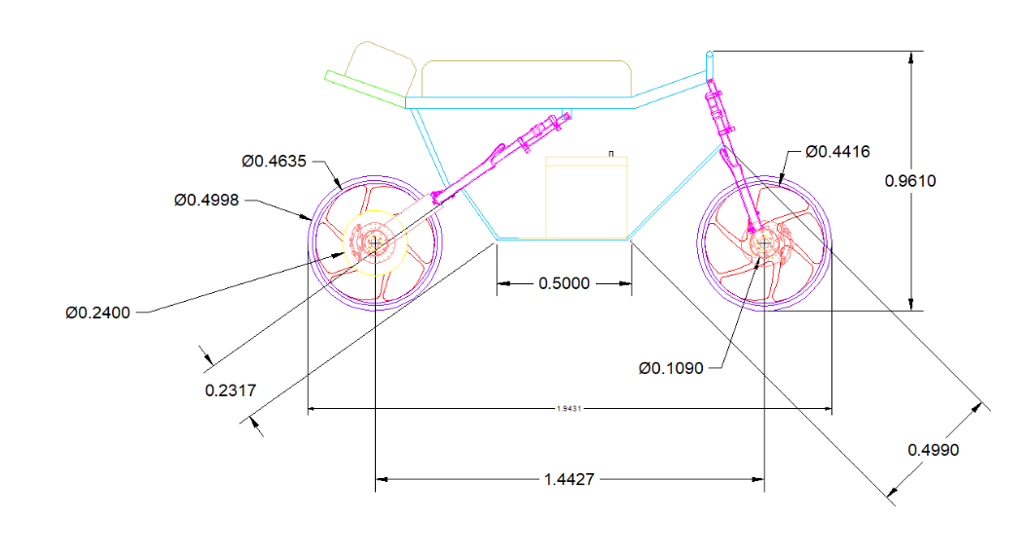
(Side View)
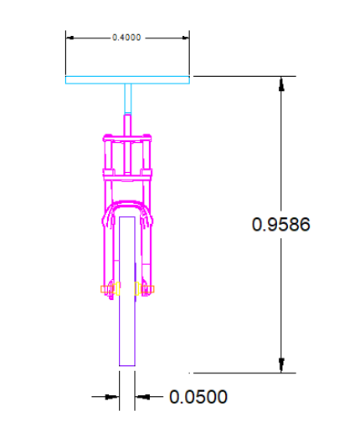
(Front View)
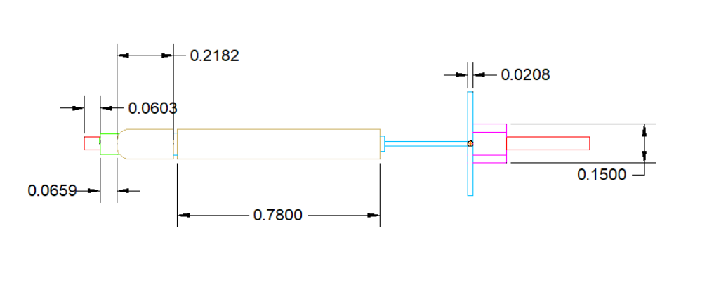
(Top View)

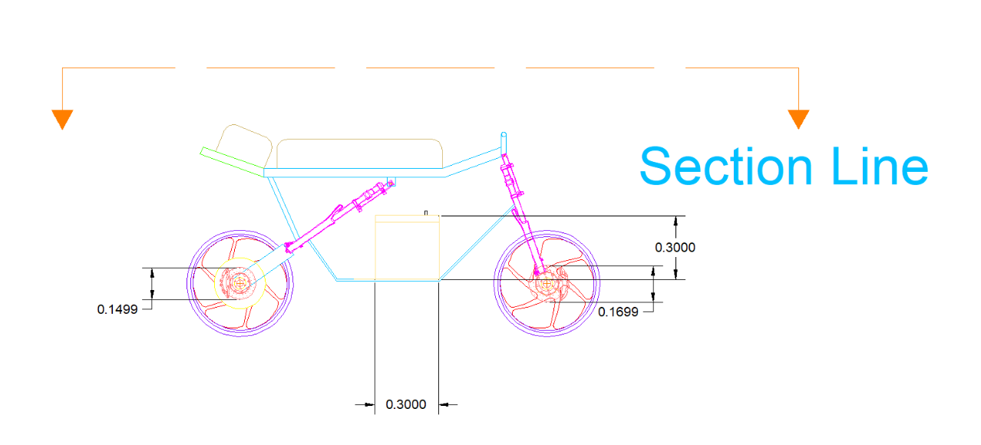
(Cutting Section Line)
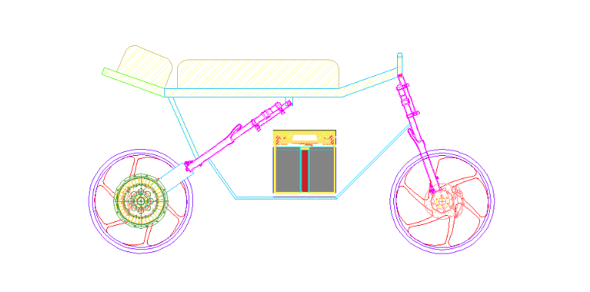
(Section View)

----------Assembly Views----------


(Battery)

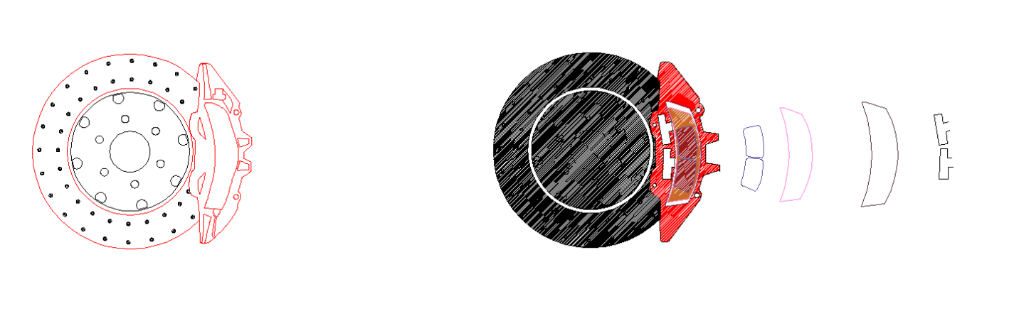
(Brembo Brakes)
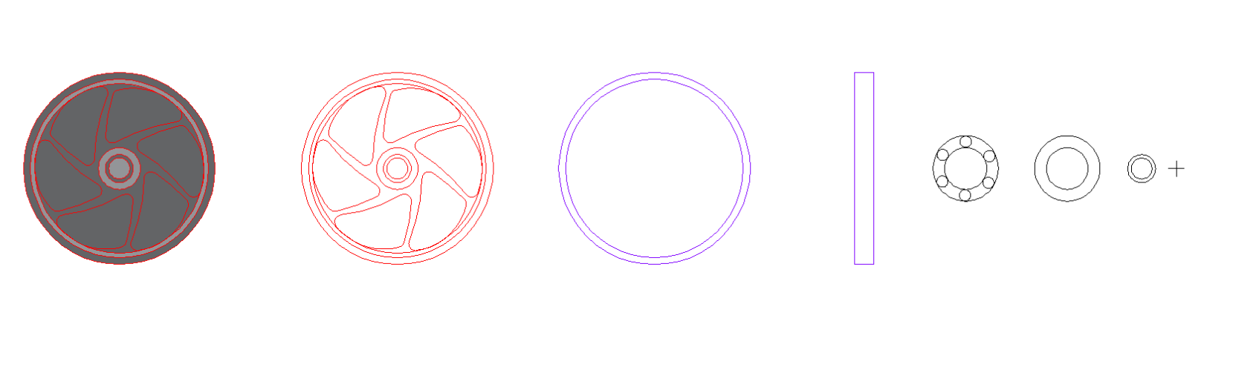
(Wheels - Tires, Rims and Axles)


(BLDC Motor)

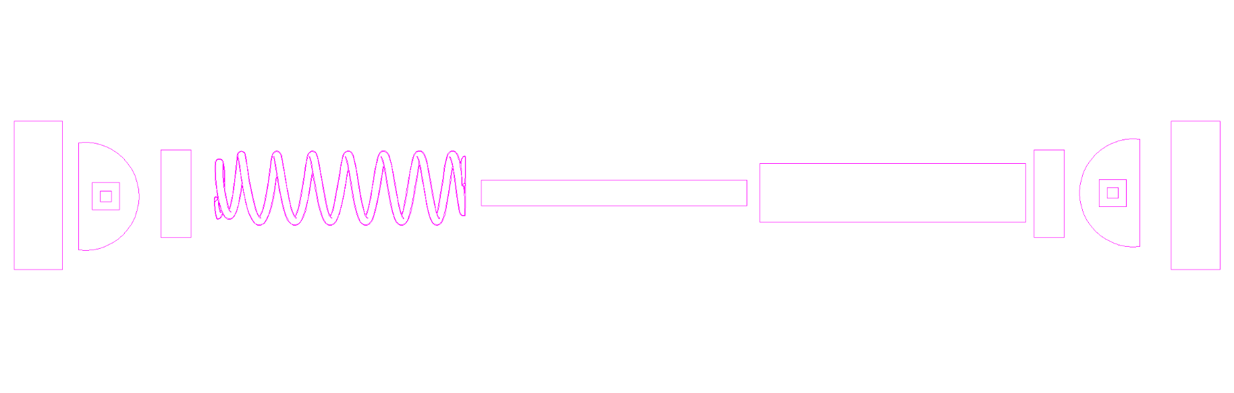
(Suspensions)

REFERENCES:

- https://www.brembo.com/en/solutions/for-original-equipement-bike/icons/stylema-caliper

- https://www.kyb.co.jp/en/products/motorcycle.html

- https://mechtex.com/blog/working-of-bldc-motor

- https://www.iqytechnicalcollege.com/BAE%20685-Electric%20Vehicle%20Technology.pdf

- https://www.sciencedirect.com/science/article/pii/S2352152X26008510?utm_source=chatgpt.com

